Task 2
1. Introduction
This report outlines the design, implementation, and analysis of a multithreaded C++ program designed to calculate the frequency of words in a given text file. The program leverages POSIX threads to divide the computational workload across multiple cores, improving execution speed for large text files. The program splits the code into chunks of data and processes them in parallel and joins the results safely.
2. Component Analysis
Functions
- Clean: A helper function that sanitizes input by removing non-alphabetic characters and converting all letters to lowercase. This ensures accurate counting.
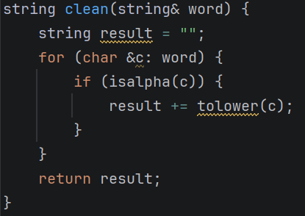

- Count: Executed by all the working threads. It iterates through its assigned lines, utilizes a stringstream to extract individual words, cleans them, and updates its local frequency map. Afterward, it locks the mutex, updates the global map, and unlocks it.
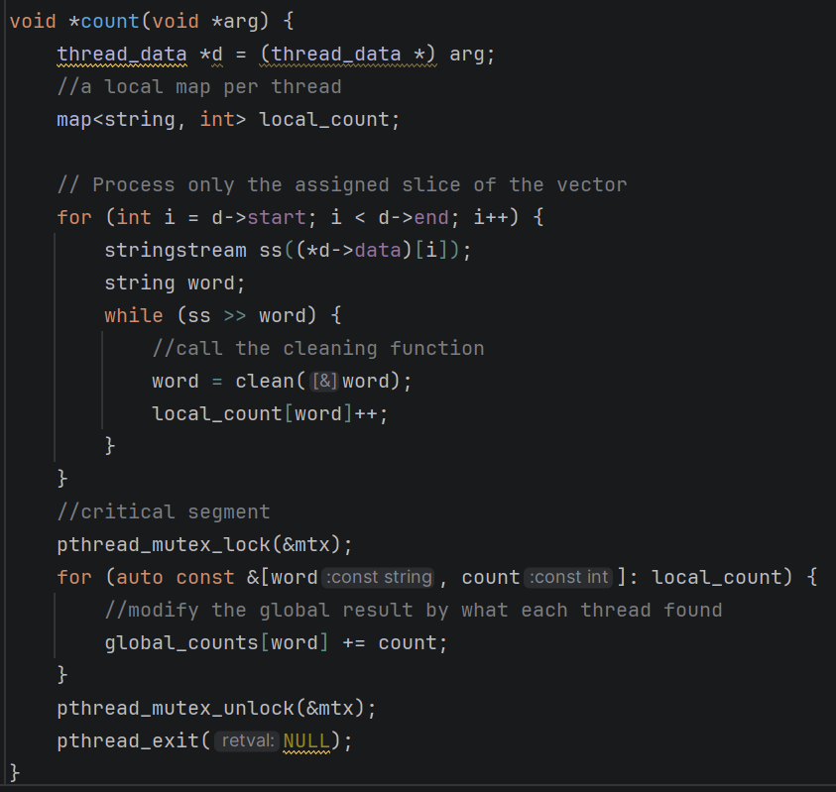

4. Execution Flow
- Initialization: The program validates command-line arguments, extracting the target filename and the optional thread count (defaulting to 4).
- File I/O: The entire file is read sequentially line-by-line into the data vector. 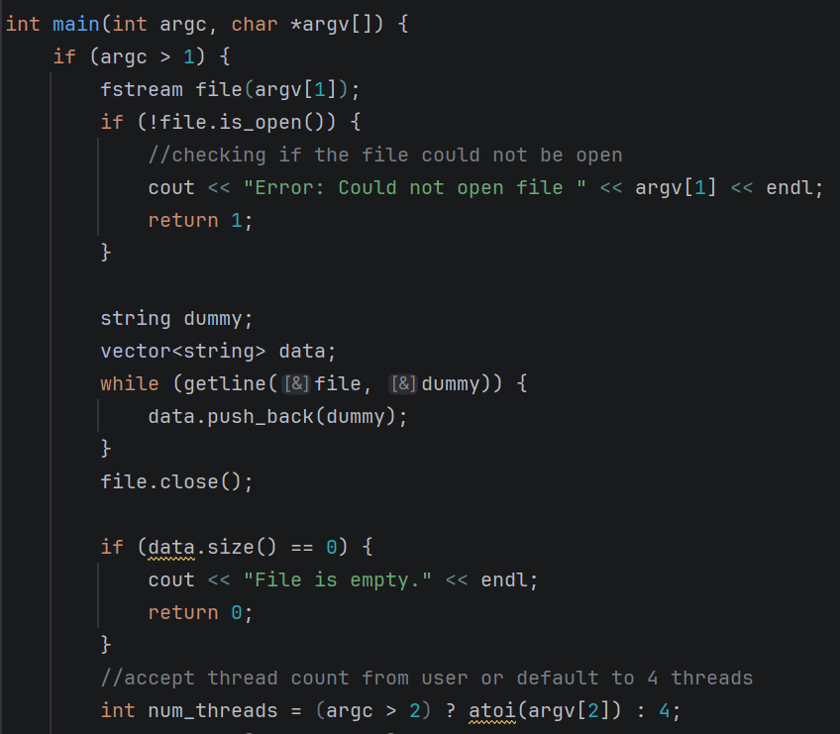

- Thread Creation & Dispatch:
The program calculates a base chunk size by dividing the total number of lines by the thread count. A time snippet is taking to measure the effect of splitting the load over different threads.
  - A loop initializes thread_data for each thread. To ensure that all the lines are processed, the last thread is explicitly assigned all remaining lines to account for integer division truncation.
  - Threads are created and their segments are passed in the form of the thread data structure.
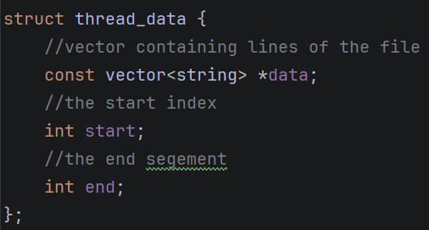

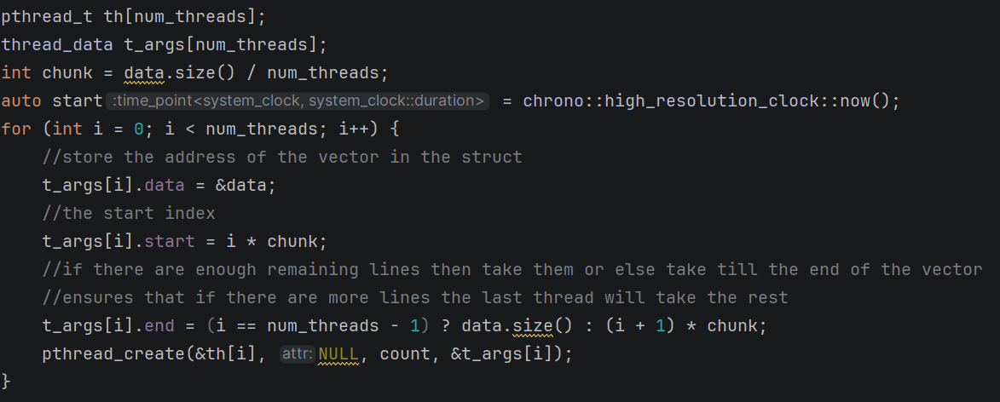

- Synchronization: The main thread calls pthread_join() in a loop, pausing its own execution until all worker threads have completed their tasks.
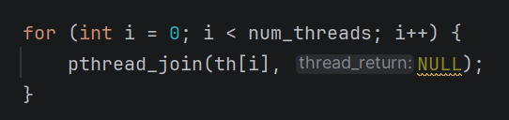
- Output: The final aggregated word counts are printed to the console alongside the total execution time.
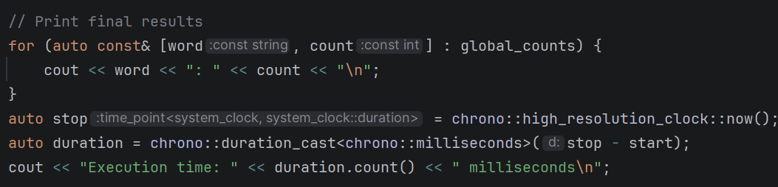
5. Performance and Concurrency Assessment
The current implementation ensures high thread safety and performance. By isolating the bulk of the computational work (string parsing, cleaning, and local counting) to thread-local variables, the program avoids creating a race condition by ensuring that each thread bulk execution is separated.
The critical section protected by a mutex lock and unlock and is kept strictly limited to the final merging of dictionaries. This ensures that the parallelized portion of the program runs at maximum efficiency.
6. Conclusion
The code implements multithreaded words count from an input text file. And the results when trying with different number of threads show a huge difference as when run with 2 threads the execution time is 130 ms. When increasing the number of threads to 20 threads, the execution time is 43 ms.
7. Github
Repo link: https://github.com/youssef1316/OS_coursework1
Commit sha: 091a17754d7004958bee9995462b739931429a9f

